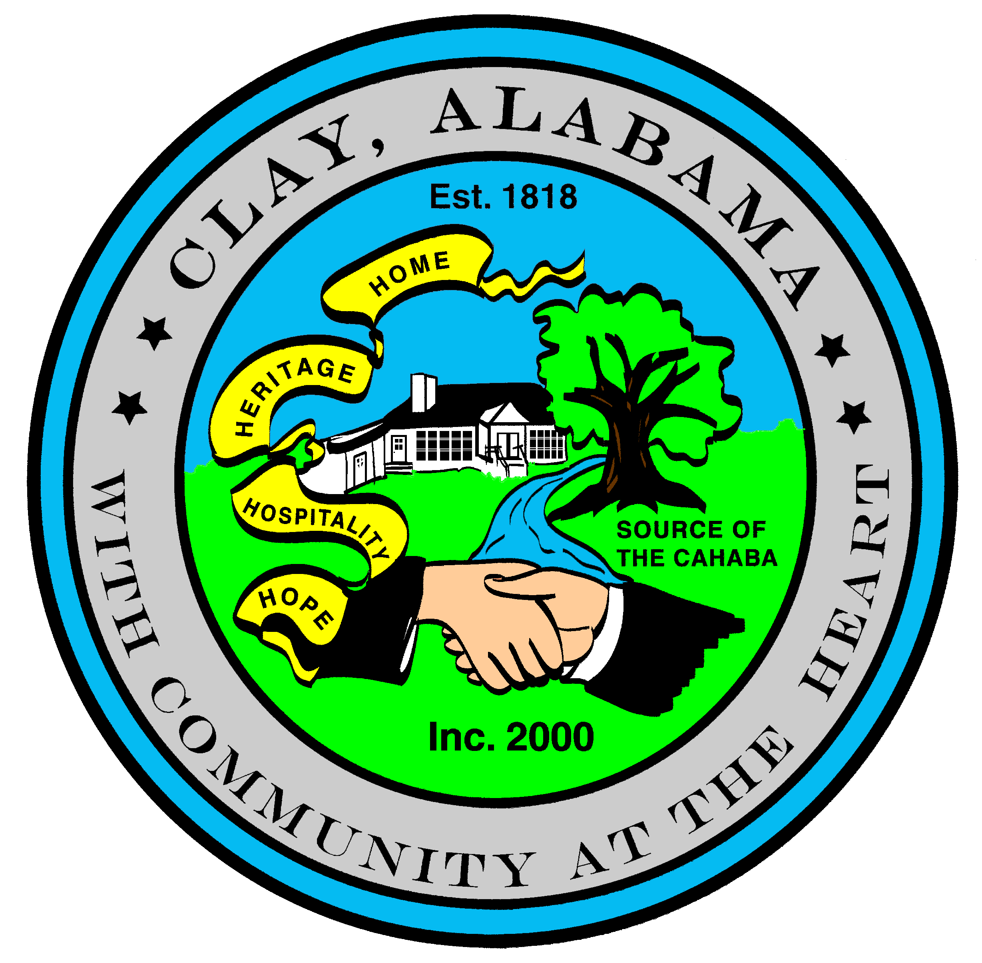
City of Clay
P.O. Box 345
Clay, AL 35048-0345
www.clayalabama.org

AGENDA
CITY COUNCIL MEETING
July 5, 2016
- Call to Order

- Prayer

- Pledge to the Flag

- Roll Call

- Approval of minutes
Pre-Council and Regular Council Minutes: June 20, 2016
- Approve Agendas
Approve Meeting Agenda
Approve Consent Agenda (Financial)

- Mayor and Council Comments
  - Mayor Webster
  - Councilor Baker
  - Councilor Becky Johnson
  - Councilor Bo Johnson
  - Councilor Small
  - Councilor Thackerson

- Reading of Petitions, Applications, Complaints, Appeals, Communications, etc.

- City Manager’s Report/Auditing Accounts
- Public Hearings
ALC 2016-02, Fred’s Store, 6501 Deerfoot Parkway

- Resolutions, Ordinances, Orders, and other business
Resolution 2016-24 A Resolution Declaring Weeds to be a Public Nuisance
Resolution 2016-25 A Resolution Releasing Liens (2010-20, 2010-32?)
Resolution 2016-25 A Resolution Rescinding Resolution 2016-20

- Public Comments

- Adjourn
Next City Council Meeting – Monday, July 18, 2016, 6:30 pm.

